WHY Dromon Bureau of Shipping
As an international Classification Society, Dromon Bureau of Shipping activities consist the application of Rules, Regulations, Standards and Guidelines for the design, construction and operational maintenance of ships & marine related structures and the subsequent verification of these standards.
DBS is in the position to meet the evolving needs of a rapidly challenging market such as the maritime industry. DBS highly trained network of surveyors and auditors can provide on-time and competent service.
DBS can guide and assist you to advance safety and improve the operational performance of your fleet ensuring minimal impact on the environment.
DromonClass can guide and provide the best options available for your fleet to meet the regulatory, technical and commercial requirements.

Who we are

Established in 2003, we have grown to be among the leading engineering serviceproviders with the objective of protecting the environment and life at sea.
Our core services consist:
-Classification of ships and other marine structures
-Statutory certification
-Environmental services under various schemes
-Independent engineering services
Through our research and development, we combine technical knowledge and digital solutions that focus on our mission to enhance safety of life, property and the environment at sea through the provisions of ship’s classifi statutory certifi and emissions verifi having quality oriented services and applying recognized standards with sound technical judgment.
As a modern classification society, we provide clever solutions, beyond class in a competent manner.

What we do

CLASSIFICATION
Classification of ships and other marine floating structures is carried out according to the requirements specifi in our Rules and Guidelines. Our Rules cover classification of all sea-going ship types, inland waterways ships and other floating structures.
Surveys include ship’s hull, machinery, electrical plants as well as refrigerated cargo installations.
Through a network of exclusive surveyors, we provide on time services, so your ship is always in compliance with our Rules and Guidelines.
We are dedicated in assuring timely compliance and ready to assist you in any technical matter by identifying potential problems.
We provide compliance through a regular survey scheme, the issuance of our Certificate of Classification and the ship’s entry into our Registry Book.
We hold knowledge that is available in the form of personnel expertise, standards, databases and competent network of surveyors ensuring adequate presence in major ports. We can guide and assist you to advance safety and improve operational performance of your ship as well as provide best options to meet the regulatory, technical and commercial requirements.

STATUTORY CERTIFICATION
We are authorized by various flag Administrations to act on their behalf for conducting surveys and issue certifi . We carry out surveys and issue statutory certifi in accordance with the IMO Conventions, Codes as well as national requirements pertaining to ship safety and the prevention of marine pollution.
We can certify your ship’s compliance with all international regulation such as:
. Safety: SOLAS, HSC Code, SPS Code
. Pollution Prevention: MARPOL, BWMC
. Management: ISM Code, ISPS Code, MLC
. International Convention on Load Lines
. International Convention on Tonnage Measurement
We are committed to safeguard compliance with all statutory regulations. Acknowledging that our industry has a complex regulatory framework we can help you in the interpretation of international and national regulations.
Understanding that cost effective service is important, we can support you in developing a survey scheme that is flexible based on your ships’ operational area and number of port calls.
Our database with Port State Control deficiencies can assist you identifying potential problems based on your ship’s area of operation. We have developed a PSC Preventive Inspection Scheme aiming identify potential deficiencies that may cause delays or non- compliance issues.
Through our network of exclusive surveyors, we render services committed to the higher standards of safety, integrity and quality. We ensure compliance with specific requirements through periodical surveys and the issuance of the appropriate certificate.

DBS is authorized by the following flag Administrations to carry out statutory certification on their behalf and issue the applicable certificate according to the IMO Conventions and Codes:

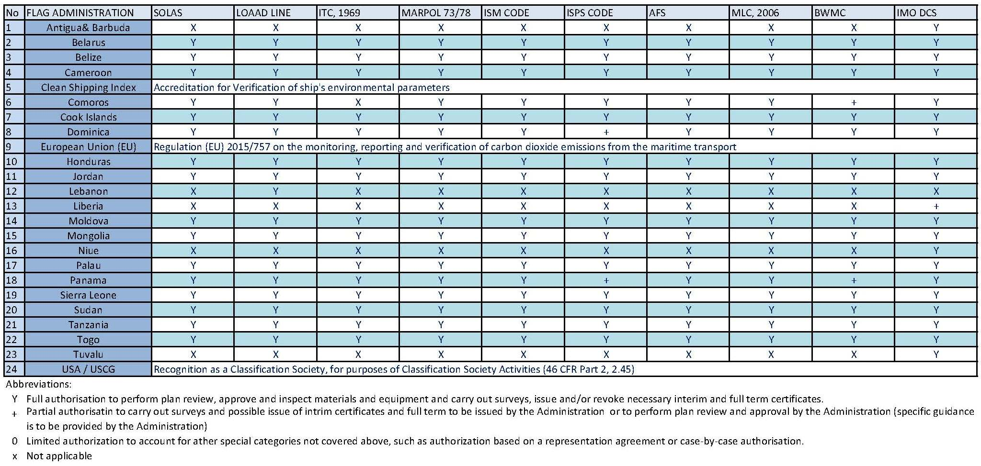

ENVIRONMENTAL
We are among the first Organizations to be accredited under the ISO 14065 and provide worldwide services related to Regulation (EU) 2015/757 on the monitoring, reporting and verification of carbon dioxide emissions from maritime transport (known as the EU-MRV Regulation). We also provide services for the IMO Data Collection System (IMO DCS) on behalf of various flag Administrations.
Since both IMO DCS and EU MRV Regulation have a number of similarities by choosing us as your single Verification Body, the verification process can take place at one audit using the same source of data therefore, reducing the regulatory burden.
On behalf of Clean Shipping Index, we can provide verification services for the environmental parameters emitted and produced from your fleet.
Data such as greenhouse gases, sulphur oxides, nitrogen oxides, chemicals and wastes harmful to the marine environment are enter to the index and verified by us.
We have developed a worldwide team of competent Verifiers that can provide services under any scheme. We have streamlined procedures to ensure compliance under any scheme without the need to duplicate information.
Been involved from day one on EU MRV Regulation we have developed extensive experience in the verification of environmental parameters.
Our Verifiers have the necessary expertise and can assist you to ensure compliance from development to application under any environmental scheme.

DIGITAL SOLUTIONS
We have developed our own platform that you can utilize to get 24/7 access to your fleet.
Through our platform you can retrieve general information of your fleet, download copies of issued certificates and approved manuals, review recommendations/ classification memos, download a complete survey status report and download copies of all Port State Control inspection reports.
The platform is free to all our clients and is developed to assist you in every day operations. Through the platform you can request surveys, get comprehensive reports with recommendations and Port State Control deficiencies so you know your ship’s profile and prepare in advance.
We are among the limited Classification Societies to have developed such a platform for our clients. We don’t embrace digitalization for digitalization sake, but we aim to assist you in every day operations. The platform is developed as a tool to make your working with us faster, easier and less time consuming.

QUALITY MANAGEMENT SYSTEM APPROVALS & Audits

We cooperate with RigCert, an ESYD accredited Body to provide the certification of quality management systems.
We can audit and certify your Company under the following ISO Quality Management System Standards:

ISO 9001 – Quality;
ISO 14001 – Environment;
ISO 45001 – Health & Safety; and
ISO 27001 – Information Security.

Our Auditors can approve your system according to RigCert procedures. Following an audit, RigCert issues a Management System Certification to your company that is evidence of compliance of your service with the relevant ISO requirements.

For more Info visit: https://www.dromon.com/services/marine/

What is a Classification society?
Nowadays there are more than fifty classification societies in the world but still the classification process and its interrelationship with international and flag regulations is not always well understood
The classification society, which is a non-governmental organisation in the shipping industry establishes and maintains technical standards for construction and operation of marine vessels and offshore structures.
The primary role of the society is to classify ships and validate that their design and calculations are in accordance with the published standards. It also carries out periodical survey of ships to ensure that they continue to meet the parameters of set standards. The society is also responsible for classification of all offshore structures including platforms and submarines.
Flag states maintain a ship register in which all ships that sail under their flag need to be registered.
Classification societies are licensed by flag states to survey and classify ships and issue certificates on their behalf. They classify and certify marine vessels and structures on the basis of their structure, design and safety standards.
Key Functions
- Setting Standards: They develop and publish technical rules (often called "Class Rules") that cover a ship's structural strength, machinery, electrical, and control systems.
- Verification & Certification: They review design plans, monitor the ship during construction, and conduct regular on-board surveys throughout its lifetime to ensure it remains seaworthy
- Statutory Compliance: They are frequently authorized by Flag States to perform statutory inspections and issue certifications on their behalf, ensuring adherence to conventions like SOLAS and MARPOL
Classification societies set technical rules based on experience and research, confirm that designs and calculations meet these rules, survey ships and structures during the process of construction and commissioning, and periodically survey vessels to ensure that they continue to meet the rules. Classification societies are also responsible for classing oil platforms, other offshore structures, and submarines.
A classification certificate issued by a classification society recognised by the proposed ship register is required for a ship's owner to be able to register the ship and to obtain marine insurance on the ship, and may be required to be produced before a ship's entry into some ports or waterways, and may be of interest to charterers and potential buyers.
To avoid liability, classification societies explicitly disclaim responsibility for the safety, fitness for purpose, or seaworthiness of the ship, but is a verification only that the vessel is in compliance with the classification standards of the society issuing the classification certificate.

What does a Class surveyor?
The Class Surveyor is a member of the technical staff of the classification society with Marine engineer, Naval Arquitecht or Naval Engineer background, incorporating sea service.
The primary task of classification society surveyors is to survey in order to maintain the standards of construction and condition of ships and machinery, which have been laid down by the society.
The secondary function of class surveyors, where their society is approved by governments, is for their surveys to be used as a basis for the issue of statutory certificates relating to safety at sea.
What they do?
- ﻿﻿Verifies that a ship is designed and built to recognized technical standards.
- ﻿﻿Conducts surveys throughout the vessel's life.
- ﻿﻿Issues and maintains class certificates.
- Supports statutory surveys on behalf of flag administrations.
Classification surveyors inspect ships to make sure that the ship, its components and machinery are built and maintained according to the standards required for their class.

What are Class Surveys?
Class surveys are formal inspections carried out by a classification society to verify that a vessel or offshore unit complies with technical standards known as “class rules.” These surveys cover the construction, machinery, and ongoing maintenance of the vessel to ensure it remains fit for service.
When you ask, What are Class Surveys?, the answer is that they are essentially the backbone of marine compliance. Without them, a vessel cannot obtain or maintain its class certificate—a key requirement for insurance, chartering, and legal operation.
What Are Statutory Surveys?
Statutory surveys of ships are mandatory inspections mandated by a vessel's flag state and international maritime laws. They ensure a ship's structure, equipment, and operations comply with global safety and environmental conventions (like SOLAS, MARPOL, and Load Line), allowing the ship to be legally certified for international trade

Why are Class Surveys Important?
Dromon Bureau of Shipping emphasise the importance of class surveys because:
Insurance Validity: Underwriters require valid class certificates to issue Hull and Machinery (H&M) and Protection and Indemnity (P&I) insurance.
Regulatory Compliance: Societies are often authorized by flag states to conduct statutory surveys confirming compliance with international mandates like SOLAS and MARPOL and ISM Code.
Commercial Operations: A vessel without active class surveys and endorsed certificates will be detained by Port State Control and lose its ability to secure cargo contracts.
Asset Protection: Regular checks (Annual, Intermediate, and 5-year Special Surveys) identify hull degradation, machinery issues, and structural fatigue, prolonging the ship's safe working life.
Protect Safety – Ensuring the structural integrity of hulls, machinery, and onboard systems keeps both crew and cargo safe.

Class surveys are inspections carried out by classification societies to ensure that a vessel meets the required standards, which are essential for maintaining the vessel’s class, and keeping the classification certificate valid, which is crucial for the vessel’s operational status.
So when vessel owners ask, What are Class Surveys and why do they matter? the short answer is: they are essential for legal, safe, and profitable operations.

